“GET INTO RECYCLING”  Taking care of the environment is the responsibility of everyone. Grayling Township is leading the way in environmental responsibility with the township recycling and composting center on North Down River Rd.  The Grayling Township Compactor will accept most any kind of household and yard wastes. All recyclable’s collected are shipped to manufacturers who will make new products. Compost your yard waste which will turn into a rich useable soil.  Help protect the environment of Grayling Township, recycle your reusable household waste at the Grayling Township Recycling Center.  The Grayling Township Recycling Center is conveniently located at 4670 West North Down River Road next to the I-75 interchange. |  |  | Your Permit Must be displayed. The attendant will check your permit when you enter and you will be turned away if permit is not displayed. |  |  | GRAYLING CHARTER TOWNSHIP RECYCLING CENTER  Compactor & Composting  4670 W North Down River Road Grayling, MI 49738  HOURS OF OPERATION  Tuesday ……………2-7pm  Thursday .………….2-7pm  Saturday ..………....9am-4pm  Sunday .…………..12-5pm  CLOSED HOLIDAYS  (989) 348-3195  Sunday……………………….….12-5pm  CLOSED HOLIDAYS  (989) 348-3195

RECYCLE  Yes: Newspapers & inserts  Yes: Newspapers, inserts, magazines, catalogs, phone books, coupons, envelopes & office paper  No: Carbon papers  Yes: Cardboard- Corrugated, pizza boxes, paperboard, cereal boxes (flatten when possible)  Yes: Plastics- #1 and #2  BOTTLE AND JUG FORM ONLY  Beverage, detergent jugs, bleach bottles, vinegar, etc. (Rinse-discard caps)  Note: #1 Clear Only  No: Oil or Hazardous material jugs  Yes: Milk Jug- Rinse discard caps and rings  Yes: Tin Cans-Rinse  No: Paint cans, aerosol cans, No METAL  Yes: Styrofoam- egg cartons  Yes: Batteries- Most sizes flashlight/household, auto, boat, mower batteries by appointment |  |  | COMPOST  Yes: Leaves & Grass Clippings  -none accepted ½ hour prior to gate closing (seasonal). All bags must be emptied.  No: Separate leaves from pine needles when possible  TRASH Not Recyclable  Personal Medical Waste – must be in puncture proof packaging and labeled prior to disposal.  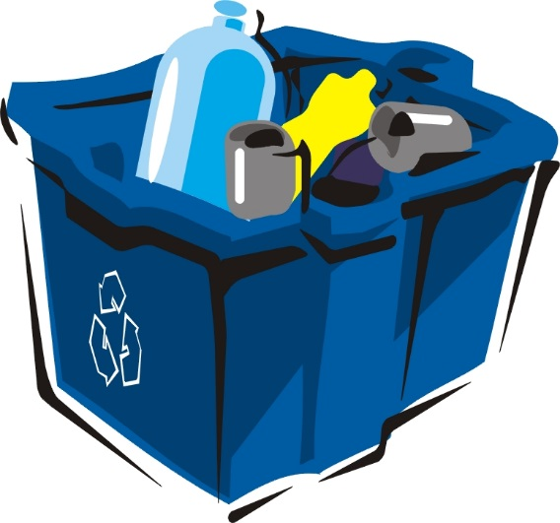 |  |  | The compactor attendant reserves the right to refuse any items he considers hazardous or inappropriate.  Your permit will allow you to dispose of the equivalent of seven, 30-gallon bags of trash and unlimited recyclable materials each week. To dispose of more than 7 bags of trash, you will be asked to pay $2.50 per additional bag.  If you would like additional permits for additional family vehicles, you may purchase them, with proof of ownership, at the Grayling Township office located at 2090 Viking way; Grayling, MI 49738.  If you have any questions or concerns about trash disposal or recycling in Grayling Township, please contact the township supervisor at (989) 348-4361 during normal business hours.

