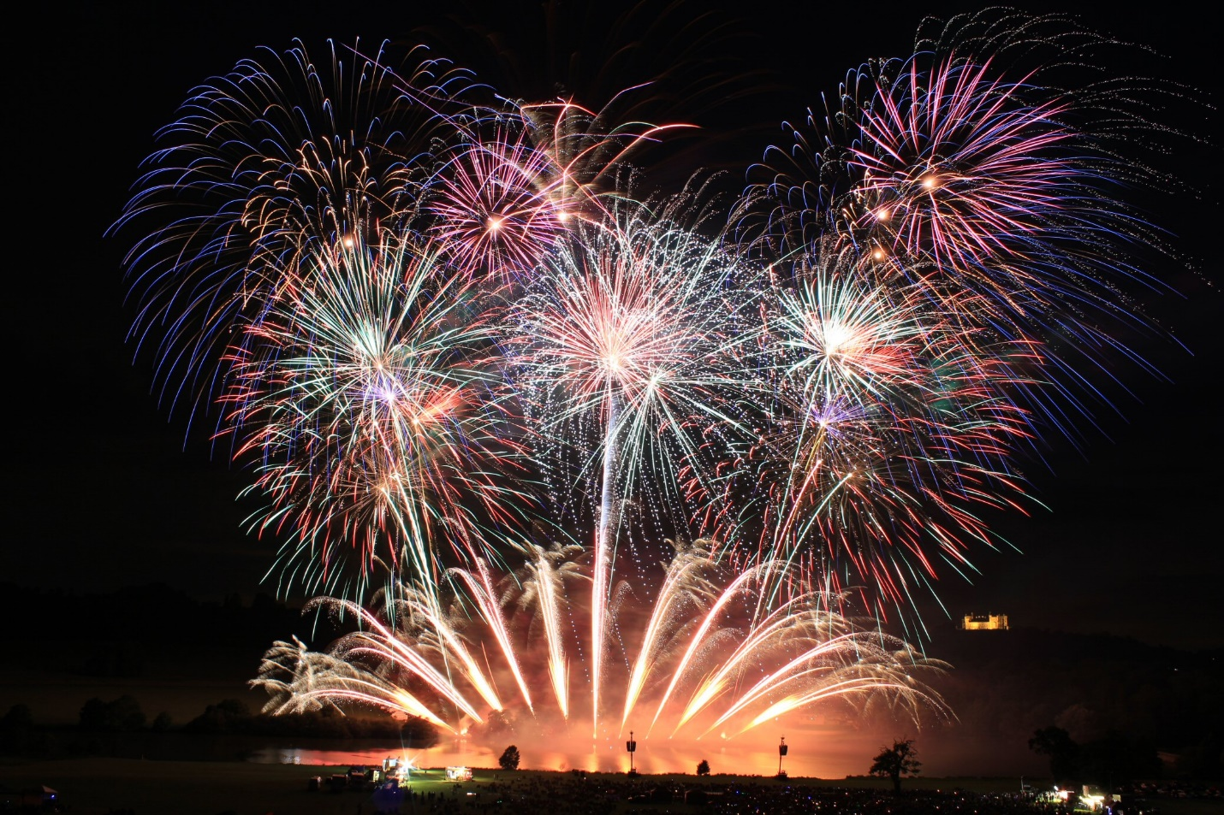
Independence Day Fireworks
Tuesday July 5, 2022 at dusk
City Park Area

The Independence Day Fireworks have always been a wonderful light display. The dedicated ALL VOLUNTEER group of Grayling Promotional Association have provided the Fireworks display over the past several years. We thank you very much.
This year the display is possible by the support of DDA (Downtown Development Association) and Grayling Chamber of Commerce.
You can be a part of making things happen in our community. We all enjoy seeing activities and improvements in our town. Things don’t “just happen” on its own, it needs you and others like you to participate, volunteer and be a part of Grayling. Contact an organization like Grayling Promotional Association, Downtown Development Association and others to make our community great.

